Rutgersson

Tel 6/12-21

Ludvig Hammarberg

**Frames for deck hatches.**

The project regards printing of the frames for deck hatches, openings in the hull. The frame is screwed in the hull structure. The opening hatch is then attached to the frame. Pls see picture. This means there will be some loads to the part.

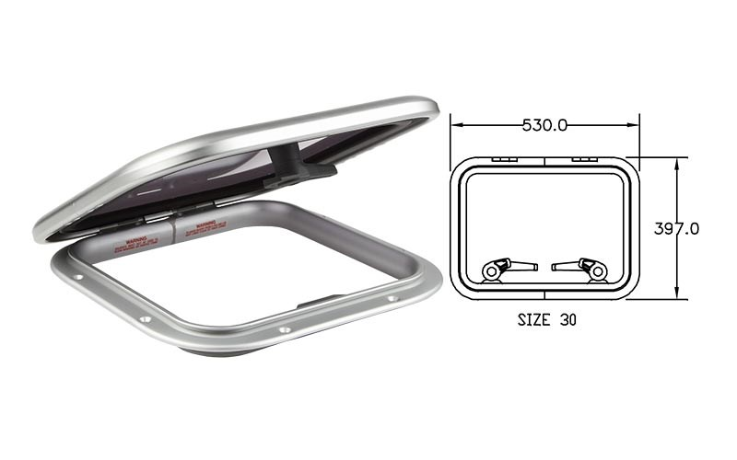

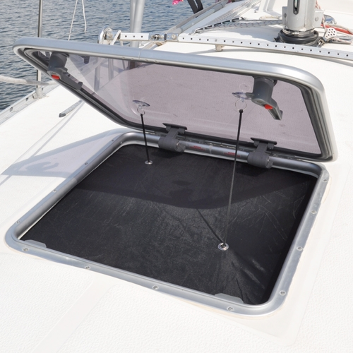

Project description:

Apart from the standard sizes, they want to be able to build small series of customized frames (varying size and geometries). Injection moulding is the normal production method for standard frames. For cost reasons, (injection molding tools), this not viable for the smaller series.

Volumes are typically in the order of ~50-500 pcs/ frame type

Material used today for standard frames can be either aluminium or 30% glassfilled PA6.

Need some stability, UV resistance plus a rather nice smooth surface.

For this specific test “Hatch frame 60 Frame”, production price must be less than >22€/ pce. In a quantity of 150 pcs. This includes the full part coated or manufactured in a UV resistent material.